Documentation on PullingZipServiceApp

Version Number:1.1

Table of Contents

Introduction: 2

Scope: 3

CI/CD Architecture: 3

Deployment Group: 3

Build Pipeline for PullingZipServiceApp 7

Pipelines: 8

Variables: 9

Tasks: 9

Publish Artifact 11

Validation 11

Release pipeline for PullingZipServiceApp 11

Steps: 11

Continuous deployment trigger: 13

Pull request trigger 13

Pre-deployment conditions : 14

Tasks: 15

Agent Job: 16

Azure powershell script:Inline Script 17

File Transform – 19

Variables: 20

Revision History: 21

# Introduction:

This is the documentation for the PullingZipserviceApp. It includes the build and release pipeline processes. Build pipelines include Nuget-related tasks, artifact generation, etc. Once the build is successful, the release pipeline starts triggering it.

# Scope:

* CI/CD is used because code can be easily deployed into a specific environment in a short period of time.
* Through the build pipeline, we can generate the artifacts, and through the release pipeline, we are able to deploy them in a specific location with the required changes.

# CI/CD Architecture:

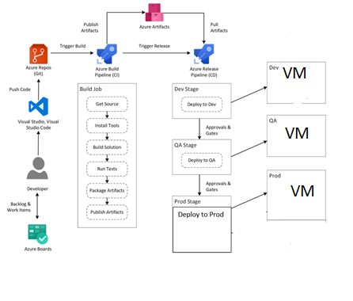

## Deployment Group:

A deployment group is a logical set of deployment target machines that have agents installed on each one.

1. Create a deployment group.

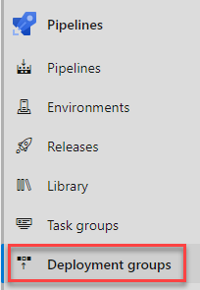

1. Select Add a deployment group

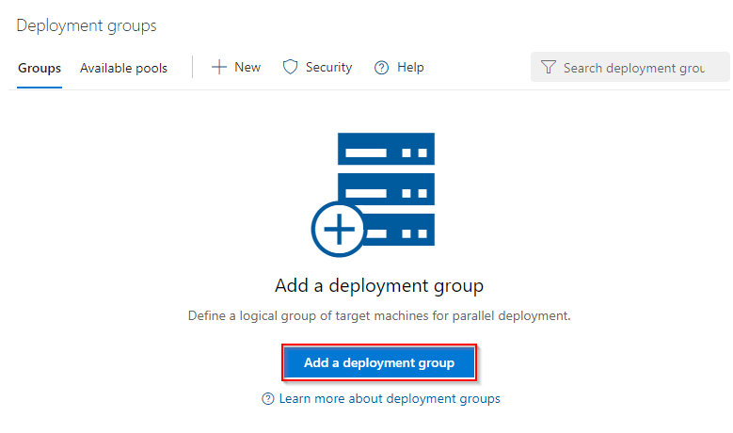

1. Enter a Deployment group name and then select Create. A registration script will be generated. Select the Type of target to register and then select Use a personal access token in the script for authentication. Finally, select Copy script to the clipboard.

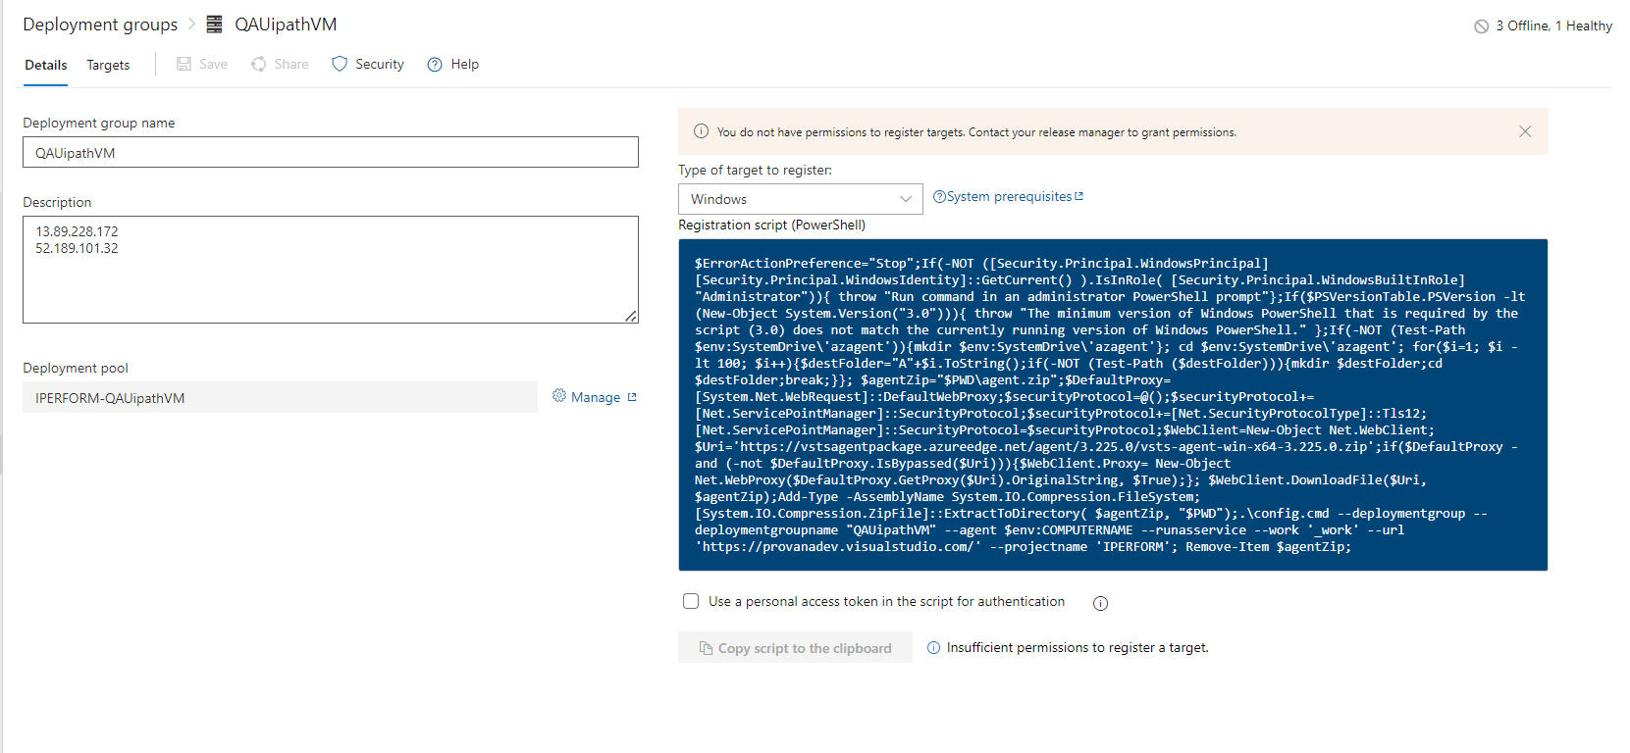

At this stage our deployment group is created but not online yet.

1. Log onto each of your target machines and run the script from an elevated PowerShell command prompt to register it as a target server. When prompted to enter tags for your agent, press Y and enter the tag(s) you will use to filter subsets of the servers.

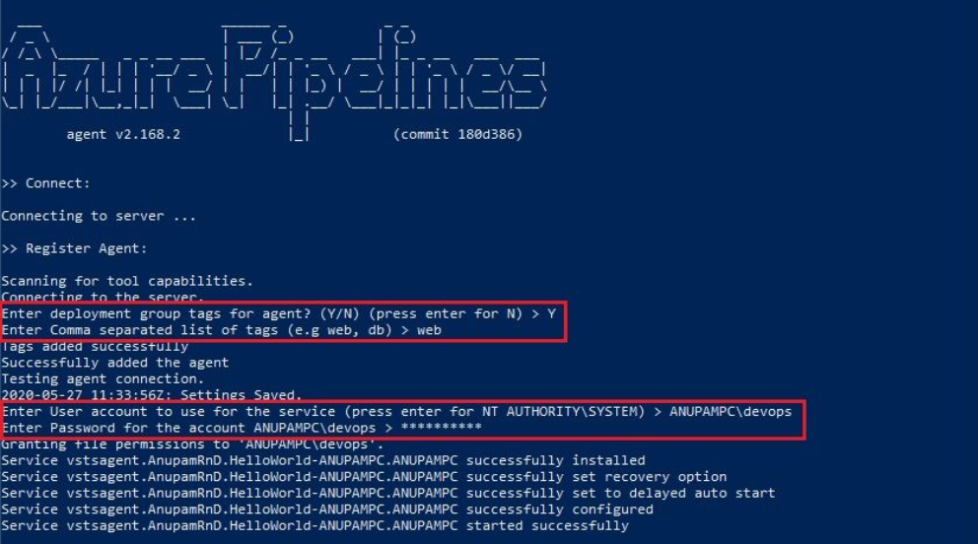

At this stage, our deployment group creation gets completed and now if you go and check the status of the deployment group in the Azure DevOps, it should show as Online.

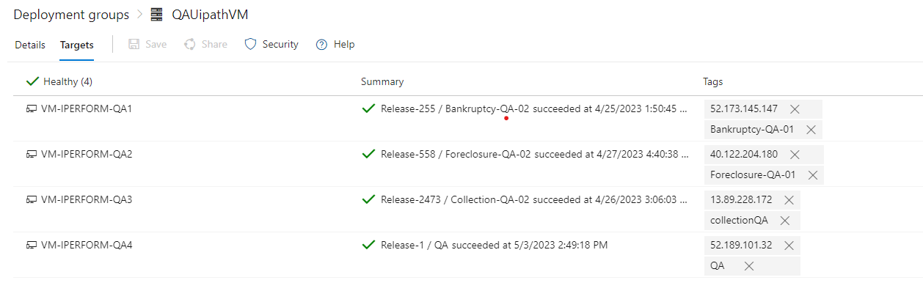

# Build Pipeline for PullingZipServiceApp

Steps:

1) Navigate the page to Pipelines and click on the “New Pipeline”.

2) Click on the “Use the classic editor”.

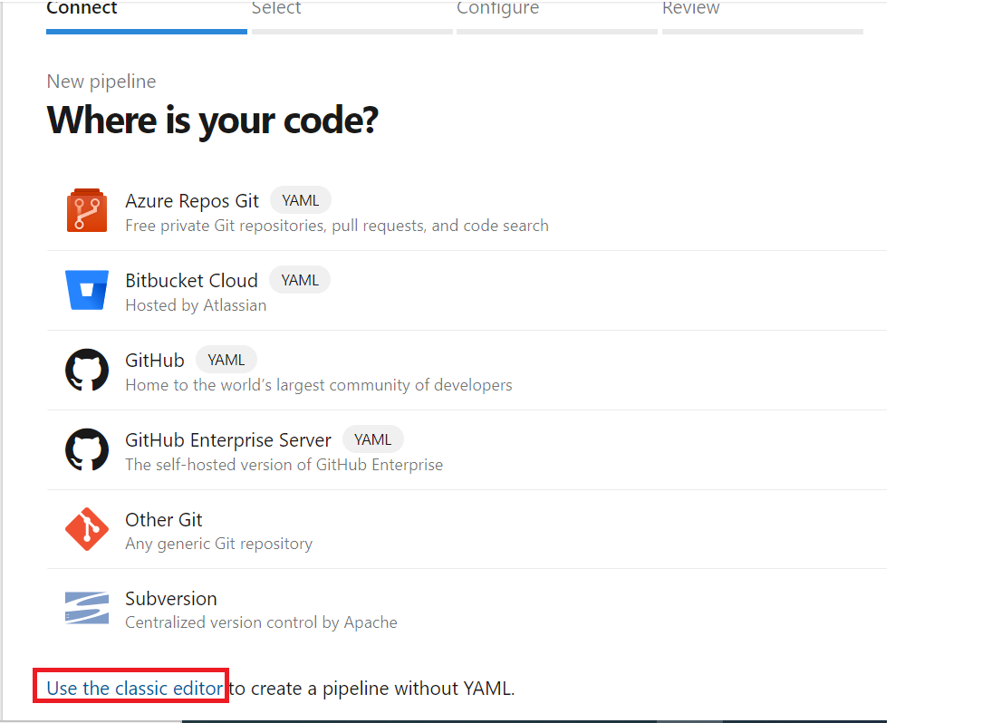

3) Select the Source as “Azure Repos Git” and followed by Project, Repository and branch.

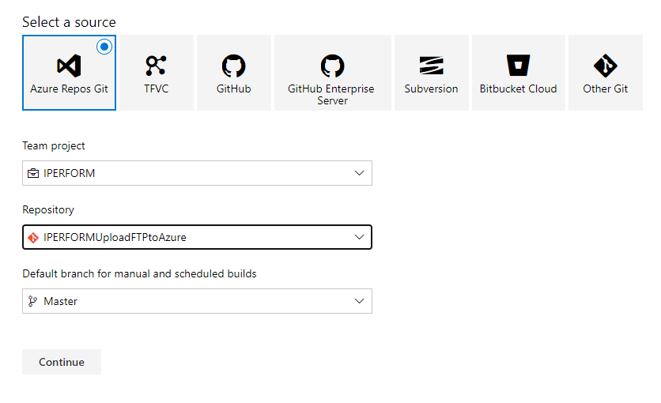

4)Select the template as “YAML”

## Pipelines:

We are using Azure pipelines (Microsoft hosted agent) as the agent pool for this pipeline. Microsoft-2019 OS version will be used in the agent.

## Variables:

you can create variables that can be used in every step of the pipeline. For builds, you could set the username and password of an external service that you want to call. Azure DevOps already comes with a couple of predefined variables like the build configuration or platform.

|  |  |  |
| --- | --- | --- |
| Variable | Description | Used in Task |
| BuildPlatform | CPU configs | Build Solution |
| BuildConfiguration | Configuration | Build Solution |

### Tasks:

NuGetCommand@2 - this task to restore, pack, or push NuGet packages, or run a NuGet command.

SonarQubePrepare@4 - This task use prepare a SonarQube analysis Configuration.

VSBuild@1 - The Visual Studio Build step builds your application using the solution file

SonarQubeAnalyze@4 - This Use this task to run the scanner and upload the results to the SonarQube server.

VSTest@2 - Use this task to run unit and functional tests (Selenium, Appium, Coded UI test, etc.

CopyFiles@2 - Use this task to copy files from a source folder to a target folder using match patterns.

# Publish Artifact

Publish Artifact is necessary for an automated deployment. This step publishes all the files which you want to deploy later in the release pipeline.

# Validation

So, here “drop’ folder should include the following files:

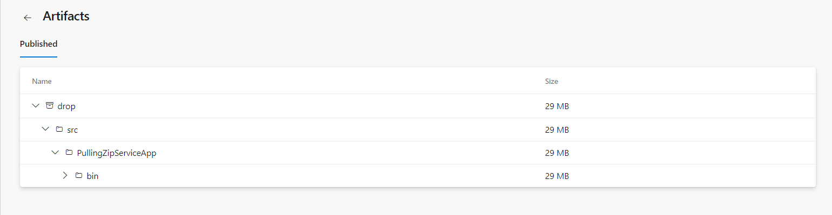

Release pipeline for PullingZipServiceApp

## Steps:

1. Navigate to release pipelines and click on “New“so as to create a new release pipeline which will be IPERFORMUploadFTP in this case.

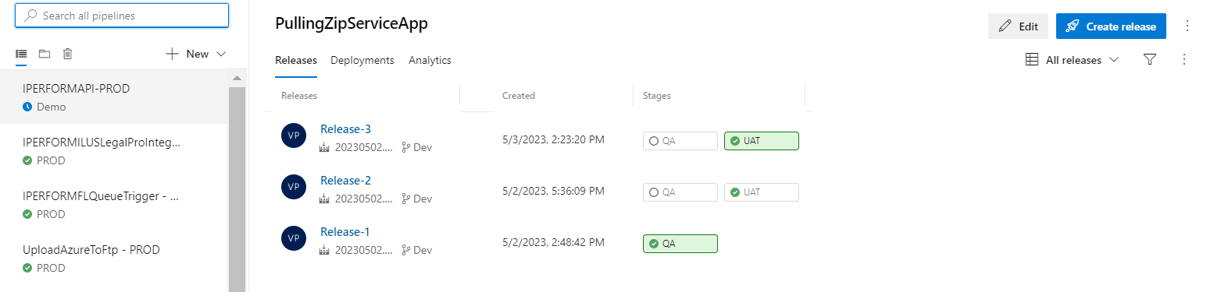

2) Select an empty job because we need to add customized jobs later which will support our project’s needs and functionality.

3)Before customizing the jobs, we will need to add the artifact that was built through our build pipeline. So, click on “Add an artifact” and then select the build pipeline which produced the artifact that is going to get used in this release pipeline.

4) As soon as the artifact is added, we must customize jobs according to the functionality of the project.

## Continuous deployment trigger:

Continuous deployment triggers allow you to create a release every time a new build artifact is available.

Note -A release will be triggered only for a build that is from one of the branches selected here.  For example, selecting "DEV" will trigger a release for every build from the DEV branch.

## Pull request trigger

Enabling this will create a release every time a selected artifact is available as part of a pull request workflow.

## Pre-deployment conditions :

Pre-deployment gates ensures there are no active issues in the work item or problem management system before deploying a build to an environment.

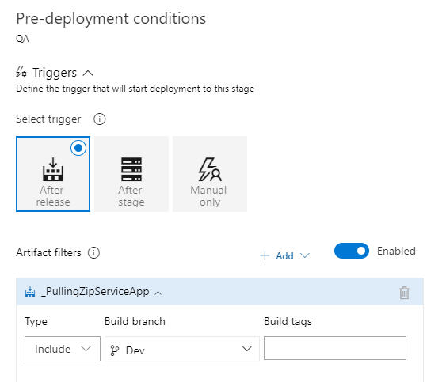

Note –

* Triggers - Set the trigger that will start the deployment to this stage automatically. Select "Release" to deploy to the stage every time a new release is created. Use the "Stage" option to deploy after deployments to selected stages are successful. To allow only manual deployments, select "Manual".
* Artifact filters - Select artifact condition(s) to trigger a new deployment. A release will be deployed to this stage only if all artifact conditions match.

Pre-deployment approvals –

Select the users who can approve or reject deployments to this stage.

## Tasks:

1. We must provide Stage Name, Azure subscription and App type and Name.

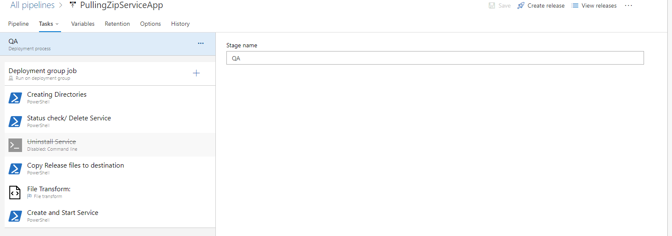

## Agent Job:

A job is a logical grouping of tasks that defines the runtime target on which the tasks will execute. An agent job executes tasks on an agent in an agent pool.

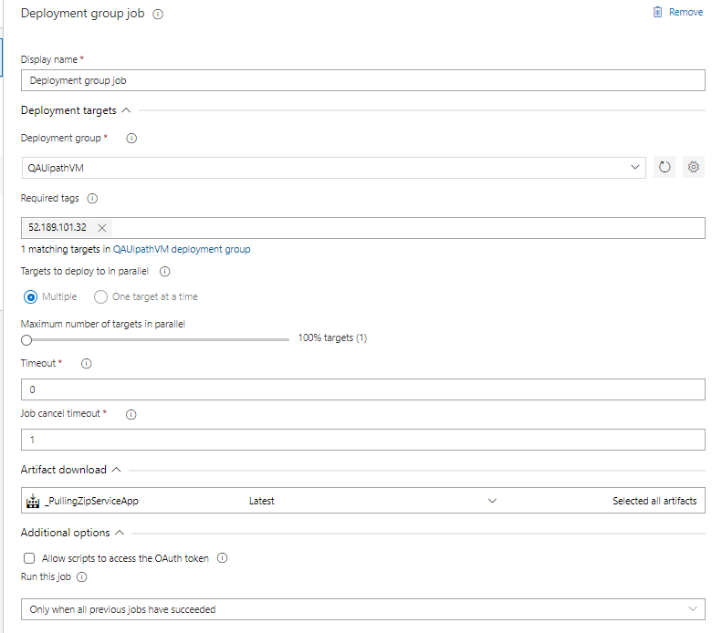

## Azure powershell script:Inline Script

The PowerShell task allows you to add PowerShell code directly within the YAML pipeline or execute an existing script in the source repo .

1. Create Directories - This task for creating Directories.

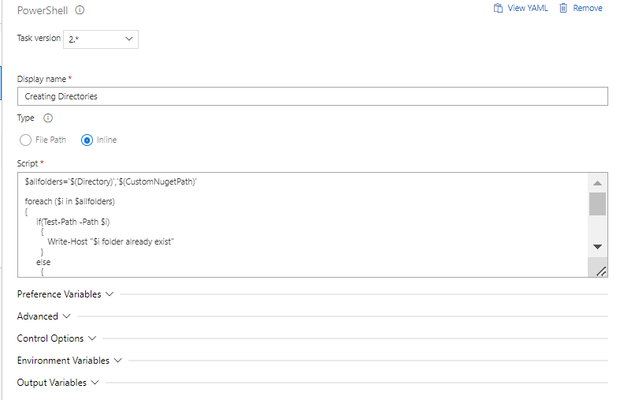

1. Status check/ Delete Service -This task for Check if service is running on VM then stop or delete.

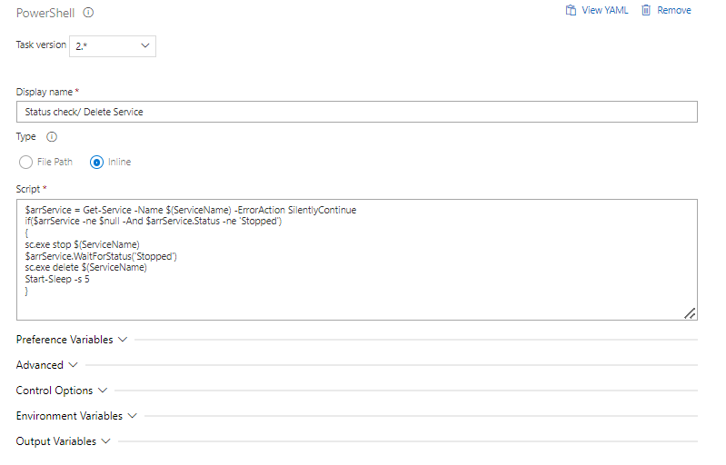

1. Uninstall Service -This task for uninstall the services.

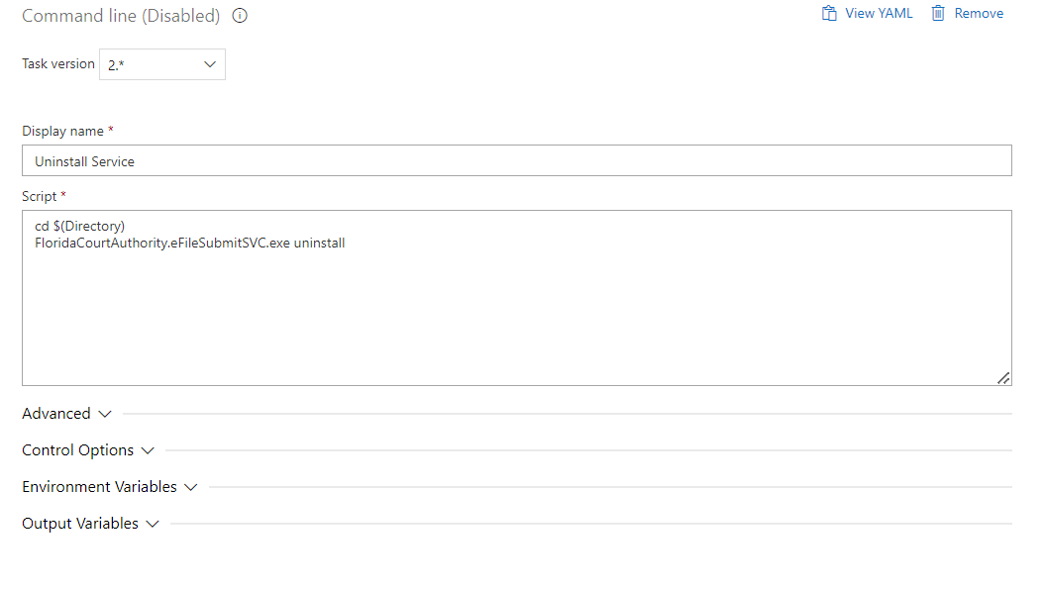

1. Copy Release files to destination -task for Copying of files from source folder to target folder

1. Create and Start Service -This task for creating and start the service.

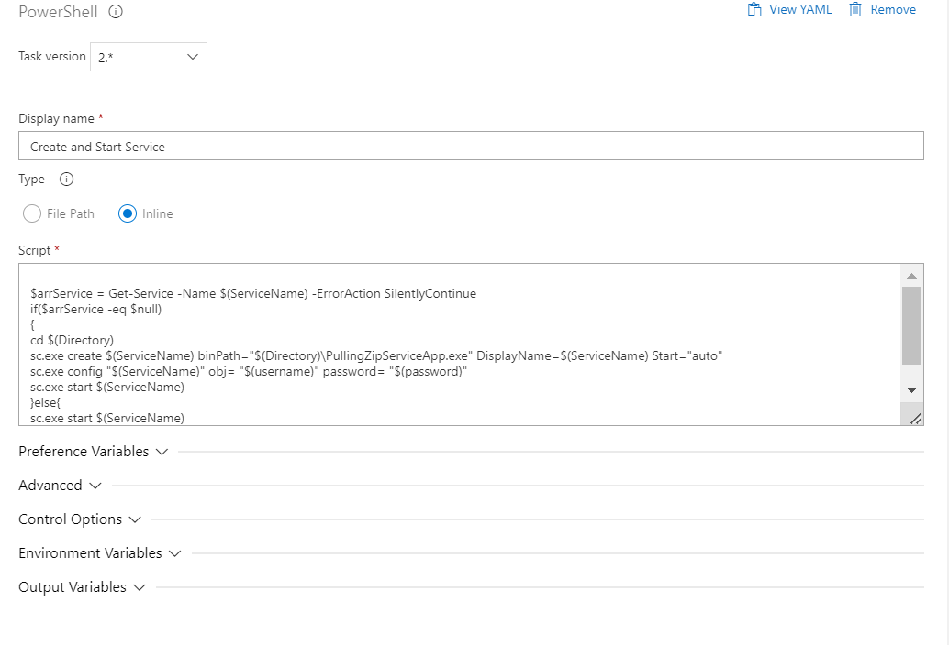

## 

## File Transform –

Use this task to replace tokens with variable values in XML or JSON configuration files.

## Variables:

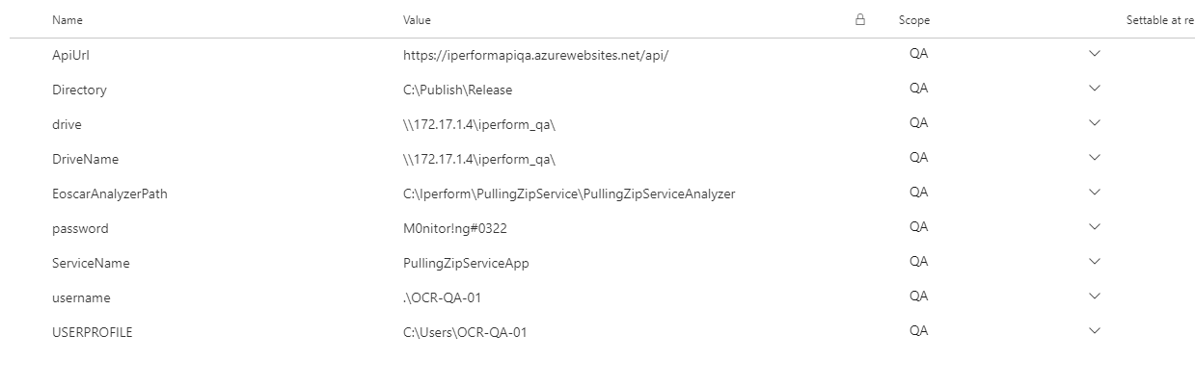

Validation

Once the release is successful, Check on VM Service is running or not.

Revision History

|  |  |  |  |
| --- | --- | --- | --- |
| **Date** | **Version** | **Description** | **Author** |
| **08/3/2023** | 1.0 | **Draft and Initial** | **Atul Sikarwal** |
| 10/05/2023 | 1.1 | **Review** | Sourabha M |